Bethelhem Arefayne, Maksym Andreiko, Umeadi Dungor

Project 3 Proposal

**Gun Violence, USA**

The aim of our project is to explore the gun violence that has occurred in the United States from 1982-2023. Gun violence and gun control are some of the most important issues that the Congress is still battling today. We’ll examine the relationships between the location, fatalities, race, total victims and gender. The data will be able to show the highest mass shooting in the country as well as the shootings per state. Through this project we may be able to uncover patterns in the ages and races of the shooter. We could see what state has the least number of shootings and can further explore the safest places to live to avoid gun violence.

The questions you’ll ask of the data

* How will we filter the data?
* What was the mental health status of the shooters?
* Could this data possibly predict future gun violence characteristics?
* Is there any correlation between location of the shooting and age of the shooter?

Tools we will be using

* Pandas
* Javascript
* PostgreSQL
* Flask-powered API
* HTML/CSS

Source of the data - Kaggle <https://www.kaggle.com/datasets/nidzsharma/us-mass-shootings-19822023>

Inspiration for visualization

View 1 Interactive Leaflet Map

View 2 Dashboard

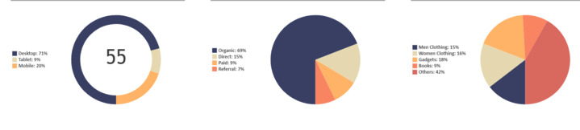

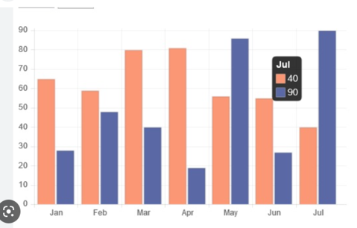 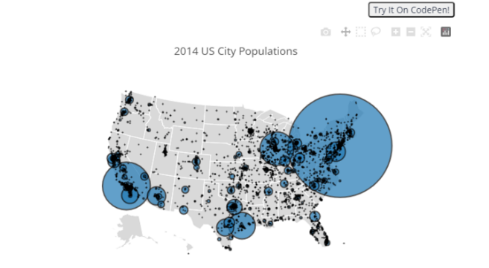

View 3 Animation Map

